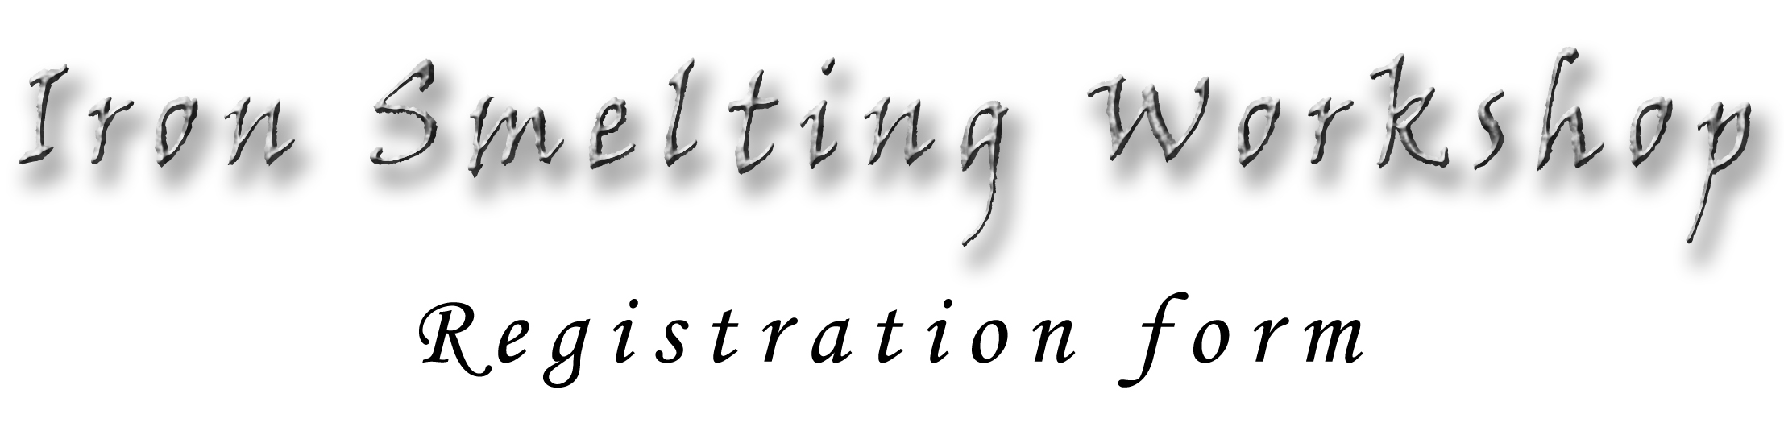

About the workshop

Place: Somogyfajsz
Meeting point is the Somogyfajsz castle. GPS coordinate: 46.503842, 17.568629
Date: 4-8th July, 2025. Please arrive to Somogyfajsz up to 12:00 for the afternoon program.
Fee: EUR 200,-
Payment can be done by cash in the spot.
More information
The program of the workshop starts at 13:00 of 4th July (Friday) and ends in the morning of 8th July (Tuesday) after breakfast. Accommodation is possible for the first 25 registered participants in the Kund hunting castle of Somogyfajsz. Most of the participants usually sleep in their tents in the camp site (ca. 1,5m far from Somogyfajsz). Breakfast, lunch and dinner are provided for each day of the camp. If you have any questions feel free to contact me per e-mail thiele.adam@gmail.com, or per mobile +36-30-374-0671.

Personal particulars
(Please answer all the questions)

Name
…………………………………………………………………………………………………...

Mobile phone
…………………………………………………………………………………………………...

E-mail
…………………………………………………………………………………………………...

Where will you come from?
…………………………………………………………………………………………………...

What means of transport will you use (car, train, bus, etc.)?
…………………………………………………………………………………………………...

Do you need accommodation in the Kund hunting castle or you will use your own tent on the camp site?
…………………

Please return this completed registration form to the following e-mail address: thiele.adam@gmail.com

